# Lab 6: Demo BeanValidation Basic.

# **Tạo** khung **chương trình:**

Tạo mới 1 project maven: VTI_Lab1.1_DemoBeanvalidation.

Tạo mới các package và class như dưới:

Package: com.vti.entity, com.vti.frontend.

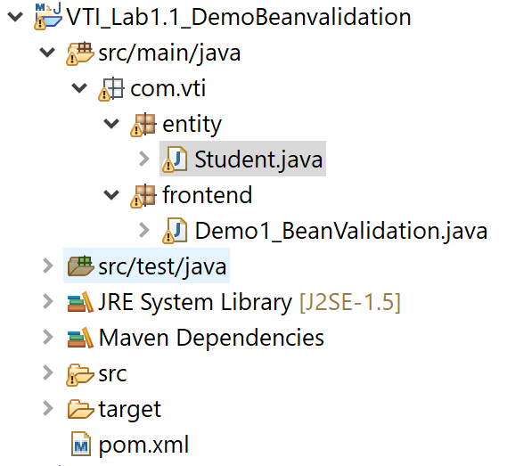

# **Thêm các cấu hình cho file: pom.xml**

|  |
| --- |
| <!-- https://mvnrepository.com/artifact/javax.validation/validation-api -->  <dependency>  <groupId>javax.validation</groupId>  <artifactId>validation-api</artifactId>  <version>2.0.1.Final</version>  </dependency>  <!-- https://mvnrepository.com/artifact/org.hibernate/hibernate-validator -->  <dependency>  <groupId>org.hibernate</groupId>  <artifactId>hibernate-validator</artifactId>  <version>6.1.5.Final</version>  </dependency>  <!-- https://mvnrepository.com/artifact/org.hibernate/hibernate-validator-annotation-processor -->  <dependency>  <groupId>org.hibernate</groupId>  <artifactId>hibernate-validator-annotation-processor</artifactId>  <version>6.1.5.Final</version>  </dependency>  <!-- https://mvnrepository.com/artifact/javax.el/javax.el-api -->  <dependency>  <groupId>javax.el</groupId>  <artifactId>javax.el-api</artifactId>  <version>3.0.0</version>  </dependency>  <!-- https://mvnrepository.com/artifact/org.glassfish.web/javax.el -->  <dependency>  <groupId>org.glassfish.web</groupId>  <artifactId>javax.el</artifactId>  <version>2.2.6</version>  </dependency>  <!-- https://mvnrepository.com/artifact/org.hibernate/hibernate-core -->  <dependency>  <groupId>org.hibernate</groupId>  <artifactId>hibernate-core</artifactId>  <version>5.4.17.Final</version>  </dependency>  <!-- https://mvnrepository.com/artifact/mysql/mysql-connector-java -->  <dependency>  <groupId>mysql</groupId>  <artifactId>mysql-connector-java</artifactId>  <version>8.0.20</version>  </dependency>  <dependency>  <groupId>com.github.v-ladynev</groupId>  <artifactId>fluent-hibernate-core</artifactId>  <version>0.3.1</version>  </dependency> |



# **Tạo Class Student trong package com.vti. entity:**

|  |
| --- |
| **package** com.vti.entity;  **import** javax.validation.constraints.Email;  **import** javax.validation.constraints.Max;  **import** javax.validation.constraints.Min;  **public** **class** Student {  @Min(value = 1, message = "ID không hợp lệ!!")  // @Positive  // @Size(min = 1, max = 3, message = "ID không hợp lệ")  **private** **int** id;  //@Min(value = 6, message = "Tên không hợp lệ!")  // @Max(value = 12, message = "Tên không hợp lệ!")  @Length(min = 6, max = 12, message = "Tên không hợp lệ")  **private** String name;  @Email(message = "Thông tin email không hợp lệ!")  **private** String email;  @Min(value = 18, message = "Tuổi không hợp lệ!")  **private** **int** age;  /**  * **@return** the id  */  **public** **int** getId() {  **return** id;  }  /**  * **@param** id the id to set  */  **public** **void** setId(**int** id) {  **this**.id = id;  }  /**  * **@return** the name  */  **public** String getName() {  **return** name;  }  /**  * **@param** name the name to set  */  **public** **void** setName(String name) {  **this**.name = name;  }  /**  * **@return** the email  */  **public** String getEmail() {  **return** email;  }  /**  * **@param** email the email to set  */  **public** **void** setEmail(String email) {  **this**.email = email;  }  /**  * **@return** the age  */  **public** **int** getAge() {  **return** age;  }  /**  * **@param** age the age to set  */  **public** **void** setAge(**int** age) {  **this**.age = age;  }  **public** Student(**int** id, String name, String email, **int** age) {  **super**();  **this**.id = id;  **this**.name = name;  **this**.email = email;  **this**.age = age;  }  **public** Student() {  // **TODO** Auto-generated constructor stub  }  @Override  **public** String toString() {  **return** "Student [id=" + id + ", name=" + name + ", email=" + email + ", age=" + age + "]";  }  } |



# **Tạo Class Demo1_BeanValidation trong package com.vti. frontend:**

|  |
| --- |
| **package** com.vti.frontend;  **import** java.util.Scanner;  **import** java.util.Set;  **import** javax.validation.ConstraintViolation;  **import** javax.validation.Validation;  **import** javax.validation.Validator;  **import** javax.validation.ValidatorFactory;  **import** com.vti.entity.Student;  **public** **class** Demo1_BeanValidation {  **public** **static** **void** main(String[] args) {  Scanner scanner = **new** Scanner(System.in);  Student student = **new** Student();  System.out.println("Chương trình quản lý sinh viên");  System.out.println("Nhập vào ID");  student.setId(scanner.nextInt());  System.out.println("Nhập vào Name");  student.setName(scanner.next());  System.out.println("Nhập vào Email");  student.setEmail(scanner.next());  System.out.println("Nhập vào Age");  student.setAge(scanner.nextInt());  // Validation  ValidatorFactory validatorFactory = Validation.buildDefaultValidatorFactory();  Validator validator = validatorFactory.getValidator();  Set<ConstraintViolation<Student>> violations = validator.validate(student);  **if** (violations == **null ||** violations.size()==0) {  System.out.println("Thông tin sinh viên vừa nhập là: " + student.toString());  } **else** {  **for** (ConstraintViolation<Student> constraintViolation : violations) {  System.out.println(constraintViolation.getMessage());  }  }  }  } |

